Rethinking Flow Theory: The Role of Learning Emotions in Computer Education

Chih-Chien Wangª, Kai-Li Wang ^{b}, and Chien-Chang Chen^{c}

ª Graduate Institute of Information Management, National Taipei University
PO Box 4-1, Sansia District, New Taipei City, 23799, Taiwan
Tel: +886-2-8674-1111 ext 66894, E-mail: wangson@mail.ntpu.edu.tw

ª Graduate Institute of Information Management, National Taipei University
151 University Rd., Sansia District, New Taipei City, 23799, Taiwan
Tel: +886-2-8674-1111 ext 66894, E-mail: kelly23695687@yahoo.com.tw

^{b} Department on Computer Science and Information Engineering, Tamkang University
No.151, Yingzhuan Rd., Tamsui District,New Taipei City 25137, Taiwan
E-mail:ccchen34@mail.tku.edu.tw

Abstract

Learning emotions are learners’ reaction to learning. Finding ways to keep learners feeling positive is an important mission for instructors. Flow theory proposed by Csikszentmihalyi in 1975 argues that the challenge-skill balance is a precondition for flow experience. When the challenge of learning is higher than the learners’ ability, the learners will feel anxiety, and when it is lower than learners’ ability, the learners will feel boredom. When the challenge of learning matches the learners’ ability, a flow experience will appear. However, the current empirical study of 110 participants reveals that emotions related to enjoyment may appear when the learners’ skill is equal to or higher than the learning challenge. Nevertheless, boredom may appear when the learners perceived the courses are difficult but unimportant. These findings revealed the necessary of rethinking the argument of challenge-skill balance and emotions of boredom and enjoyment in flow theory.

Keywords:
Computer-based Instruction, Flow theory, Emotion, E-learning, Challenge-skill balance.

Introduction

Learning emotions are learners’ reaction to learning. Learners can be distracted due to the learning course are not fit their skill. Negative emotions during courses may weaken learners’ motivations to learning. Thus, educators should find ways to keep learners in the positive emotion and avoid negative emotion during learning.

Flow Theory

Flow theory by Csikszentmihalyi subjectively explore the well-being of people during engagement in an activity, may be used to explore the generation of positive emotions during such activities. Flow is a metaphorical term [1] that refers to an optimal experience resulting in intense engagement, distorted sense of time, and heightened motivation [2, 3]. People fully engage in what they are doing and experience enjoyment when they are in the flow state [4].
People in the flow state will have complete focus and a feeling of control, passion and fulfilment during the activity. Csikszentmihalyi (1975) proposed the three channel model of flow to discriminate between human affective states (flow, anxiety, and boredom) during activities they involved in. If the challenge is perceived as beyond the individual’s skill, the activity generates anxiety; on the other hand, if the individual’s skill is beyond the challenge, the person might fall into a state of boredom. Only if the perceived challenge and perceived skill are equivalent or similar, will a flow state appear. The flow state occurs when the challenge and skill are balanced.

Flow Theory in Learning

The concept of flow is widely used in learning. For example, Hwang, Wu and Chen [5] designed an effective learning system to promote students’ flow experiences during web-based problem-solving activities. Pearce, Ainley and Howard [6] used flow to explore learning activities in an online learning environment. Ho and Kuo [7] indicated that flow experience has a positive effect on learning outcomes.

Challenge-Skill Balance

Achieving a challenge-skill balance is one of the preconditions for flow experience [2, 8, 9]. The original flow theory revealed that the flow state occurs when there is a challenge-skill balance: If one’s skill cannot meet the challenge, the overwhelming activity generates anxiety; on the other hand, if the challenge decreases and one’s skill exceeds the challenge, one might come to a state of boredom. Only if the perceived challenge and perceived skill are equal or approximately equal, will a flow state appear.

Emotion and Challenge-Skill Balance

According to flow theory, a challenge-skill balance is essential in learning materials in order to attract learners’ attention. When learners perceive a challenge-skill balance in learning materials, they are in the flow state, which will generate positive emotions. However, learners may feel anxiety if they perceive the learning materials as too difficult; and boredom if the learning materials are too easy, according to flow theory.
Nevertheless, in educational practice, some learners may feel boredom rather than anxiety when they perceive learning materials as more difficult than their ability; this does not match the prediction of the flow theory. Task importance may be a possible moderator of the relationship between the challenge-skill balance and learning emotion. Learners who consider the learning activity as difficult but unimportant may feel boredom rather than anxiety. In this case, they do not feel anxiety since they perceive the task as having a low value for their learning. To our knowledge, however, no previous study has focused on the moderating effect of task importance on the influence of the challenge-skill balance on learning emotion.
In addition, flow theory advocates that learners will feel boredom when the challenge of the learning material is lower than the learners’ ability. However, in practice, learning materials with a low difficulty level may provide learners with a sense of achievement.

Research Purpose

The present paper aims to explore the associations between challenge-skill balance, task importance, and learning emotions in a computer-based learning environment. We investigated whether the difficulty of learning materials and perception of task importance can lead to different learning emotions, which were correlated to learning performance.

Methods

The research aims to determine learners’ positive and negative emotions in learning. We explore the conditions required for the appearance of enjoyment, anxiety, boredom, frustration and correlation between learning emotion and learning outcome. We adopted a longitude study to explore the relationship between learning emotion and learning performance. The independent variable, challenge-skill balance and task value were an important antecedent to predict learning emotion. The dependent variables, learning performance was the consequences of learning emotion. Table 1 lists the method, sample size and purposes of the current research.

Table 1 – Empirical Study

Method | Sample size | Purpose
Questionnaire survey | N=110 | To explore the learning emotion of relationship between two stages, one is before midterm exam and the other is after that. The effect of performance on learning emotion was revealed in this study.

Participants

Participants of the study were undergraduate students majored in computer science and enrolled in the courses of algorithm and computer programming. All of them joined the study voluntarily and were informed of their right to leave at any time. The study recruited participants from the classes of algorithm and computer science since that the learning challenge increase along with the stage of semester.
110 participants joined the study, including 89.0% male and 11.0% female, ranging in age from 20 to 25 years. The gender ratio of the study was similar to that of the department: according to the student enrollment data, 89.1% of the students in the department were male. The average age of respondents was 20.23 years with the standard deviation of 1.95.

Procedure

The participants were asked to fill out a questionnaire on the challenge-skill balance, flow experience, task value, and learning emotions at the first half of the semester. In order to investigate the shift of learning emotion, we carried out a longitudinal study compose of two questionnaire surveys for the same participants at the first half of the semester and the week next to the middle term exam.
Figure 1 - Procedure of data collection

Measures

The questionnaire was comprised of four main parts, including flow experience, challenge-skill balance, learning emotion and task value. The study used flow experience was developed by Shin [10] to measure learners’ flow experience dimensions of enjoyment, telepresence, focused attention, and time distortion. There were three items for each flow dimension. The measurement scale of Shin (2006) is adapted from previous flow research [11-15]. We adopted “involvement” as a replacement which based on Novak, Hoffman and Yung [14]’s conceptual model to substitute for the statements of measurement items of “engagement” dimension of flow in Shin [10], because engagement was not appropriate for the present study. We adopted involvement dimension that was measured by Saxena, Khurana, Kothari and Jain [16]. All of the items were measured on a 7-point Likert scale, from 1 (Strongly Disagree) to 7 (Strongly Agree).

Reliabilities and validity

The study calculated Cronbach’s alphas to measure the reliability of the scales. The Cronbach’s alphas of enjoyment, telepresence, focused attention, involvement, time distortion were .93, .86, .83, .87, .92, respectively. All of the reliability values exceeded 0.70, which were well within the acceptable range.
This study assessed convergent validity by examining the average variance extracted (AVE) of each dimension. The results showed that all AVE values in this study were well above the value of 0.5 suggested by Fornell and Larcker [17]. Therefore, we confirmed the convergent validity of the measurement scales. Discriminant validity refers to the extent to which evaluations of different constructs are unique from each other [18]. The discriminant validity was examined through correlation among measurement scales.
The AVE values of enjoyment, telepresence, focused attention, involvement, time distortion were .80, .79, .86, .74, .52, which represent the variable possess a good convergent validity. The square root of AVE value must be greater than other variables correlation coefficients. As shown in Table 2, the square root of AVE in each measurement scale is greater than correlation coefficients, indicating that the discriminant validity has been accepted.

Table 2 - Reliabilities and validity
 | AVE | Alpha | 1 | 2 | 3 | 4 | 5
Enjoyment | .80 | .93 | .89
Telepresence | .79 | .86 | .70** | .89
Focused Attention | .86 | .83 | .47** | .57** | .93
Involvement | .74 | .87 | .73** | .64** | .41** | .86
Time Distortion | .52 | .92 | .43** | .48** | .33** | .49** | .72
Note: ** p<0.05; values in bold are square root of AVE

Data Analysis

All participants were asked to fill out a questionnaire on the challenge-skill balance. To explore the impact of challenge-skill balance on learning emotions in the class of algorithm and computer science, we divided the participants into two groups based on their perceived challenge-skill balance. If participants felt that the level of learning challenge was higher than their skill, they were placed into the hard level of difficulty group; if their perceived challenge level was lower than or equal to their ability, they were placed into the easy level of difficulty group.
We divided the participants into three groups based on their perceived challenge-skill balance to explore the impact of challenge-skill balance on learning emotions. If participants felt that the level of learning challenge was higher than their skill, they were placed into the hard level of difficulty group; if their perceived challenge level was equal to their ability, they were placed into the balance group; if their perceived challenge level was lower than their ability, they were placed into the easy level of difficulty group.
The three groups were compared through a series of one-way ANOVA analysis. Table 3 reveals that enjoyment, anxiety and frustration scores were significantly different between the easy, middle and hard level of difficulty groups. When participants regarded the learning materials as easy and middle, the subjects’ average enjoyment level was 5.55 (SD=0.76) on the 7-point scale. The average score of enjoyment was 5.53 (SD=0.87) when the participants regarded the material as middle and the average score of enjoyment was 4.70 (SD=1.04) when the participants regarded the material as hard. Participants felt enjoyment when they perceived that learning was easy. The average scores of anxiety on the seven point scales were 2.39 (SD=0.74) for participants who felt that the learning was easy, 2.88 (SD=1.00) for those who felt it was middle and 4.40 (SD=1.05) for those who felt it was hard. The average score of boredom was 2.23 (SD=0.73) for participants who regarded the learning materials as easy, 2.39 (SD=0.91) for those who regarded the learning materials as middle and 3.12 (SD=1.07) for those who regarded the learning materials as hard. The average score of frustration was 2.04 (SD=0.73) for participants who regarded the learning materials as easy, 2.36 (SD=0.95) for those who regarded the learning materials as middle and 3.39 (SD=0.96) for those who regarded the learning materials as hard. The more difficult the perception of the lesson, the more anxiety, frustration, and boredom the participants felt.
The average scores of flow on the seven point scales were 4.72 (SD=0.63) for participants who felt that the learning was easy, 4.90 (SD=0.82) for those who felt it was middle and 4.20 (SD=0.79) for those who felt it was hard. The results confirmed that learners who perceived challenge-skill balance might achieve higher flow experience. When the participants regarded the learning materials as easy (below their original ability) or hard (above their original ability), less possibility of flow experience they might achieve.

Table 3. Emotion, flow and level of difficulty
 |  | Level |  |  | ANOVA analysis | Post Hoc  test
 |  | Easy  (N=23) | Middle  (N=40) | Hard  (N=47) | ANOVA analysis | Post Hoc  test
Enjoyment | Mean  S.D | 5.55  0.76 | 5.53  0.87 | 4.70  1.04 | F=11.191  P=.00* | Easy, Middle > Hard
Anxiety | Mean  S.D. | 2.39  0.74 | 2.88  1.00 | 4.40  1.05 | F=43.038  P=.00** | Easy, Middle < Hard
Boredom | Mean  S.D. | 2.23  0.73 | 2.39  0.91 | 3.12  1.07 | F=9.380  P=.00** | Easy, Middle < Hard
Frustration | Mean  S.D. | 2.04  0.68 | 2.36  0.95 | 3.39  0.96 | F=22.787  P=.00** | Easy, Middle < Hard
Flow | Mean  S.D. | 4.72  0.63 | 4.90  0.82 | 4.20  0.79 | F=9.411  P=.00** | Easy, Middle > Hard
* p<0.05; ** p<0.01

The Figure 2 reveals that enjoyment, anxiety, boredom, frustration and flow scores were significantly different between three levels of difficulty groups. The less difficult the perception of the lesson, the more enjoyment the participants felt. The more difficult the perception of the lesson, the more anxiety, frustration, and boredom the participants felt. Anxiety was affected by level of difficulty more significantly. When challenge and skill were balance, the participants reported higher flow experience than unbalance ones (too easy or too hard).

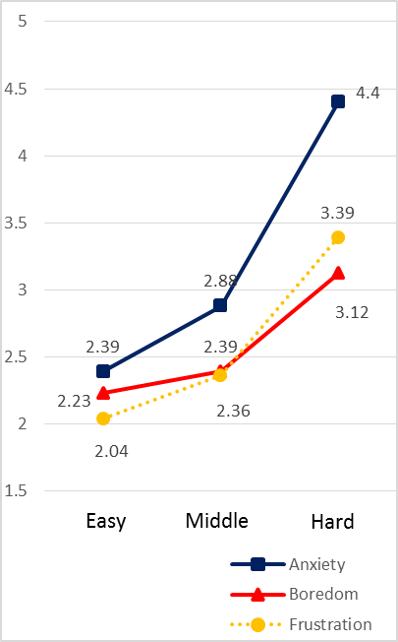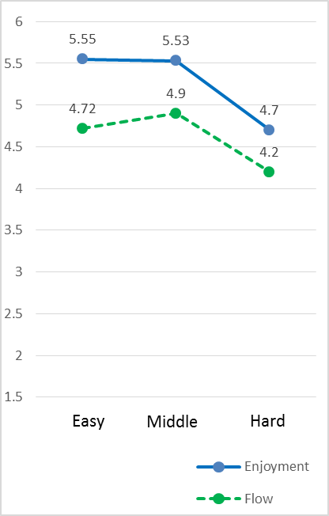

(a) Flow and Positive Emotion (b) Negative Emotion

Figure 2 - Emotion and level of difficulty

We divided the participants into two groups of high and low importance perception based on the participants’ task value score to reveal the impact of learning task value on learning emotion. Since a seven point Likert type scale was used to measure task value, we used a mean score of 4 as the cut off point for high and low importance perception. The score 4 was Classified as low importance group.
Table 4 reveals that those in the high importance group showed a higher level of enjoyment (Mean=5.38, SD=0.91) than those in the low importance group (Mean=4.44, SD=1.01). The average score of flow was 4.77 (SD=0.76) in the high importance group, and 3.84 (SD=0.68) in the low importance group. Furthermore, the low importance group showed a higher level of boredom (Mean=3.46, SD=1.14) than the high importance group (Mean=2.45, SD=0.88). Participants who regarded the learning as highly important experienced enjoyment during the learning; and participants who regarded the learning as of low importance felt boredom. There was no significant difference in anxiety levels between the high and low importance perception groups. Task value is a significant determinant of enjoyment, flow and boredom. However, anxiety was not significantly influenced by task value perception.
Figure 3 shows the mean differences between the four groups in different level of challenge and importance. The learning performance with high importance in easy group (Mean=86.19; SD=13.77) was higher than hard group (Mean=67.45; SD=21.92). Likewise, the learning performance with low importance in easy group (Mean=72.06; SD=21.40) was higher than hard group (Mean=64.92; SD=20.56). Table 5 reveals that the scores of learning performance were significantly different with different level of challenge and importance. Subjects’ learning performance decreased along with the level of learning materials, and increased along with the level of importance. The more importance the lesson, the more performance the subjects obtained.

Table 4. Emotion and task value importance perception
 |  | Importance |  | t-test results
 |  | Low  (N=24) | High  (N=86) | t-test results
Enjoyment | Mean  S.D | 4.44  1.01 | 5.38  0.91 | t=4.350  p=.00**
Anxiety | Mean  S.D. | 3.88  1.20 | 3.30  1.30 | t=-1.937  p=.06
Boredom | Mean  S.D. | 3.46  1.14 | 2.45  0.88 | t=-4.653  p=.00**
Frustration | Mean  S.D. | 3.18  1.06 | 2.61  1.04 | t=-2.346  p=.02*
Flow | Mean  S.D. | 3.84  0.68 | 4.77  0.76 | t=5.42  p=.00**
*p<0.05

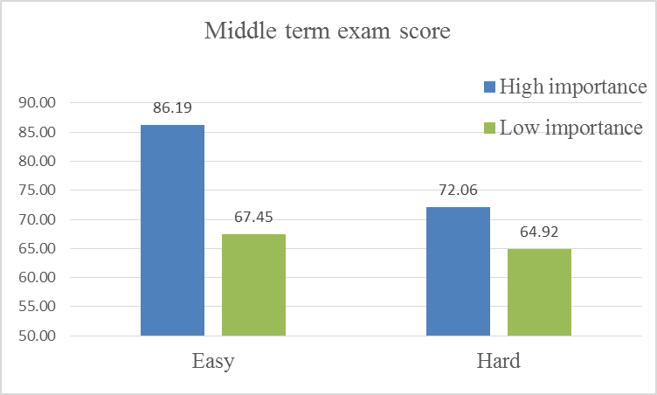

Figure 3 - Performance between different level of challenge and importance groups

Table 5 - Performance of different level of challenge and importance
 | Challenge |  | Importance |  | Two-way ANOVA
 | Easy  (n=63) | Hard  (n=47) | Low  (n=24) | High  (n=86) | Challenge | Importance | Challenge x  Importance
Performance  Mean  S.D. | 78.74  2.73 | 67.22  2.87 | 66.56  3.79 | 79.40  2.04 | F=10.23  P=.00** | F=8.85  P=.00** | F=10.86  P=.00**
*p<0.05; **p<0.01

Discussion and Conclusion

Discussion

The study examined the impact of learning emotion on learning performance. The results indicated that learners who regarded the course as easy positively correlated with positive learning emotion, flow experience and high performance. These findings support the argument that positive learning emotion has a positive effect on learning outcomes. Learners who regarded the learning materials as hard would appear negative learning emotion like anxiety, boredom and frustration. Both level of learning materials and importance were high, learners would appear anxiety and frustration. The current study aimed to determine learners’ positive and negative emotions in the courses of algorithm and computer programming and the conditions required for the appearance of enjoyment, anxiety, boredom, and frustration. The current study found that boredom may occur when the learning material is difficult but perceived as unimportant. Moreover, learners with negative emotion would have low performance. Thus, the empirical survey results reveal that low performance learners feel a higher level of anxiety, boredom, and frustration than others is supported.
Besides, we explore the impact of learning performance and learning emotion measured after test. The study showed that learners’ learning emotion after test was closely correlated with learning emotion and learning performance. Also, performance would strengthen the level of emotion. Learners with high positive emotion would get high performance. Learners with negative emotion will get low performance. In addition, learners with high importance will get higher performance than learners with low importance. Accordingly, it seems reasonable to conclude that providing learners with a suitable learning material is necessary and let learners to know learning material is useful to them and importance.
The empirical survey results reveal that boredom may appear when the learners perceived the courses are difficult but unimportant. When the course is difficult, learners may feel boredom as well as anxiety. If learners regard the learning as unimportant, they may feel boredom when the learning content is difficult. In this situation, there may be a trend for learners to discontinue their learning, since they cannot complete the learning contents and feel that the learning content is unimportant. However, if learners regard the course as important, they will feel anxiety when they perceived the course is difficult. In this situation, learners may try, but fail, to complete the learning content. Anxiety and frustration may appear in this situation. High performance would strengthen the level of learners’ positive emotion. On the contrary, low performance would strengthen learners’ negative emotion and let learners perceive the course as unimportant. Based on the results of the empirical survey, we suggest that instruction development should avoid developing learning material that is beyond the learners’ ability, especially when some learners regard the course as unimportant.

Theoretical Contribution

The current research contributes to the extant literature and practice in several ways. First, the current research confirms that challenge-skill balance and importance are an essential antecedent to appear positive and negative emotion. Although some previous studies [19, 20] had proposed and investigated such relationship, these previous studies did not pay attention to learners’ emotion after exam and got performance.
Besides, the research found that boredom may occur when the learning material is difficult but perceived as unimportant, which contradicts the forecast of the flow theory. Flow theory is widely used in learning to discuss the impact of flow experience on learning outcomes. It forecasts that anxiety will occur when the learning challenge is beyond the learners’ skill. Statistical analysis of the results of the present study confirms this argument. However, flow theory forecasts that boredom will occur when the learning is too easy. Observations in educational practice, some learners may feel boredom rather than anxiety when they perceive learning materials as too difficult for their ability. Boredom did not only appear when the challenge level was lower than the skill level, but also when the challenge level was higher than the learners’ skill level and the importance of the lesson is perceived as low. The result is inconsistent with the thoughts of flow theory.

Limitations and suggestions for future research

In light of our ﬁndings, certain limitations and suggestions for future studies should be considered. First, the current research found that boredom may occur when the learning material is difficult but perceived as unimportant. However, the present research does not oppose the possibility that boredom will occur when the learning content is too easy as flow theory forecast. The learning materials of experimental design and the courses of computer science may be not easy enough to let learners appear boredom. Future studies can focused on the area of boredom (personal skill is beyond the challenge). Therefore, researchers who are interested in learning emotion can design an adaptive material for learners. If learners can receive a moderate learning content, their positive emotion and learning outcomes may also increase obviously.
Second, the learning environment in current research in study was the courses of algorithm and computer programming which were taught by different teacher. Nevertheless, it is probable that lots of factors like instructional factors and the standard of score are also influence learners’ emotion. Even the learning materials were difficult to learners, they did not worry about their score and appear negative emotion. Therefore, researchers who are interested in flow can design an identical e-learning material for learners to decrease external factors.

Reference

[1] M. Kawabata, and C. J. Mallett, “Flow experience in physical activity: Examination of the internal structure of flow from a process-related perspective,” Motivation and Emotion, vol. 35, no. 4, pp. 393-402, 2011.
[2] M. Czikszentmihalyi, “Flow: The psychology of optimal experience,” Praha: Lidové Noviny. Cited on page, 1990.
[3] H. Chen, “Flow on the net–detecting Web users’ positive affects and their flow states,” Computers in human behavior, vol. 22, no. 2, pp. 221-233, 2006.
[4] D. L. Hoffman, and T. P. Novak, “Flow online: lessons learned and future prospects,” Journal of Interactive Marketing, vol. 23, no. 1, pp. 23-34, 2009.
[5] G.-J. Hwang, P.-H. Wu, and C.-C. Chen, “An online game approach for improving students’ learning performance in web-based problem-solving activities,” Computers & Education, vol. 59, no. 4, pp. 1246-1256, 2012.
[6] J. Pearce, M. Ainley, and S. Howard, “The ebb and flow of online learning,” Computers in Human Behavior, vol. 21, no. 5, pp. 745-771, 2005.
[7] L. A. Ho, and T. H. Kuo, “How can one amplify the effect of e-learning? An examination of high-tech employees’ computer attitude and flow experience,” Computers in Human Behavior, vol. 26, no. 1, pp. 23-31, 2010.
[8] M. Csikszentmihalyi, "Beyond boredom and anxiety; the experience of play in work and games.," San Francisco: Jossey-Bass, 1975.
[9] M. Csikszentmihalyi, and R. Larson, “Validity and reliability of the experience-sampling method,” The Journal of nervous and mental disease, vol. 175, no. 9, pp. 526-536, 1987.
[10] N. Shin, “Online learner’s ‘flow’experience: an empirical study,” British Journal of Educational Technology, vol. 37, no. 5, pp. 705-720, 2006.
[11] S. E. Yager et al., “Microcomputer playfulness: stable or dynamic trait?,” ACM SIGMIS Database, vol. 28, no. 2, pp. 43-52, 1997.
[12] J. Steuer, “Defining virtual reality: Dimensions determining telepresence,” Journal of communication, vol. 42, no. 4, pp. 73-93, 1992.
[13] J. A. Ghani, “Flow in human computer interactions: Test of a model,” Human factors in information systems: Emerging theoretical bases, pp. 291-311, 1995.
[14] T. P. Novak, D. L. Hoffman, and Y.-F. Yung, “Measuring the flow construct in online environments: a structural modeling approach,” The ELab at Vanderbilt University, 1998.
[15] Y. X. Skadberg, and J. R. Kimmel, “Visitors’ flow experience while browsing a Web site: its measurement, contributing factors and consequences,” Computers in human behavior, vol. 20, no. 3, pp. 403-422, 2004.
[16] A. Saxena et al., “Development of a “Flow Process Scale” to Measure Flow Among Web Users,” Journal of Internet Commerce, vol. 2, no. 4, pp. 55-86, 2004.
[17] C. Fornell, and D. F. Larcker, “Evaluating structural equation models with unobservable variables and measurement error,” Journal of Marketing Research (JMR), vol. 18, no. 1, 1981.
[18] R. P. Bagozzi, “An examination of the validity of two models of attitude,” Multivariate Behavioral Research, vol. 16, no. 3, pp. 323-359, 1981.
[19] S. D’Mello, and A. Graesser, “Dynamics of affective states during complex learning,” Learning and Instruction, vol. 22, no. 2, pp. 145-157, 2012.
[20] S. Lichtenfeld et al., “Measuring students' emotions in the early years: The Achievement Emotions Questionnaire-Elementary School (AEQ-ES),” Learning and Individual differences, vol. 22, no. 2, pp. 190-201, 2012.

