Blood Vessels by Fractal Gelatin

Lung-Jieh Yang*, Bo-Hong Chen
*Department of Mechanical and Electromechanical Engineering, Tamkang University, TAIWAN
Ljyang@mail.tku.edu.tw

Abstract—In this study the authors developed a novel gelatin patterning technique applied to making blood vessel with fractal dendrite configuration. Such a chaotic tree-like pattern has been obtained through precipitating among the gelatin matrix which is spun coating on a glass substrate at room temperature. The weight percentage of the original gelatin solution is over-saturated. As the temperature decrease, the gelatin crystallizes and forms a natural fractal pattern in the thin film. The process parameters are changed and the hydraulic diameters of the fractal patterns are verified from 0.1 μm to 23 μm. Finally the authors used the biocompatible PDMS making blood vessel like capillary channels by the de-molding process of the soft lithography. The filling test of the PDMS fractal channel chip is done accordingly.
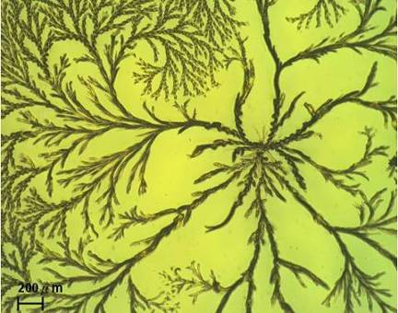
Fig. 1. The gelatin fractal patterns in the K₂Cr₂O₇-gelatin collagen matrix [4].
Keywords-gelatin; blood vessels; fractal; PDMS

Introduction
Artificial blood vessels are important to the implant surgery subject to many irrecoverable damages of human organs. The material for the blood vessels should meet the requirement of good bio compatibility and long life time. Any polymer material extracted from the animal tissues or natural creatures seems more suitable to implant applications other engineering materials. One choice of them is gelatin which poses 18 kinds of amino acid and can be shaped into different geometries or patterns in the previous studies correlated with the weak microstructure strengthening and the selective stem cell culture [1-2]. In these prior arts, the gelatin micro patterns are very regular according to the designers’ mask layouts hence far from the bio mimicking manner, e. g., the fractal patterns discussed in this paper. In other words, if we regard the gelatin as a material for making the artificial blood vessels to mimic the fractal-like capillary blood vessels, developing fractal gelatin patterns seems the first difficulty needed to be overcome.
Fractal patterns are commonly found during the re-crystallization process of over-saturated salty solution [3]. In NEMS-2011, the authors have ever chosen the gelatin aqueous solution dissolved with excess amount of a photo-sensitizer agent, potassium dichromate (K₂Cr₂O₇) [1] to occasionally generate the tree-like, fractal micro structures. One example is shown as Fig. 1 [4-5]. The classical weight percentage of the gelatin aqueous solution for generating the fractal gelatin is 10-20 wt%, with the matching amount of K₂Cr₂O₇ as 5-15 wt%. In our prior art [4-5] the confinement effect mentioned by R. Feynman was investigated to influence the repetitive characteristics of the gelatin fractal patterns and its application to the design of micro mixers. In this paper, however, the authors would like to use gelatin fractal pattern to fabricate some chaotic capillary channels for liquid transportation and even more as the promising artificial blood vessels in the future.

Fabrication and Experiment

How to Make the Fractal Gelatin
The gelatin solution needs gentle heating up to 50-60°C with proper mixing and bubble removing. Spin coating is accessed to spread the gelatin film on a glass substrate. The dispensing time of the gelatin gel on the substrate should be controlled as short as possible to avoid gelatin solidification before the uniform spin coating. The re-crystallization happens no sooner than the completion of spin coating, and proceeds for proper duration corresponding to different concentrations of gelatin solution.
A variety of fractal gelatin patterns corresponding to different process parameters are observed in this work. These process parameters are the spin-coating (500, 1000, 1500, 2000 rpm), the weight percentages of gelatin (10, 15, 20 wt%), and the weight percentages of K₂Cr₂O₇ (5, 10, 15 wt%).

Process Parameters of the Fractal Gelatin
In this work, the authors specifically evaluated the hydraulic diameters of the gelatin fractal patterns as the characteristic length. The hydraulic diameter D_{h} of the fractal gelatin according to different process parameters are shown Fig. 2. Each datum value of Fig. 2 is obtained by averaging at least 5 measured points from one gelatin sample. The error bar of each datum is also evaluated as well. The cross section of a fractal gelatin tree-like branch bumped and embedded in the
(a)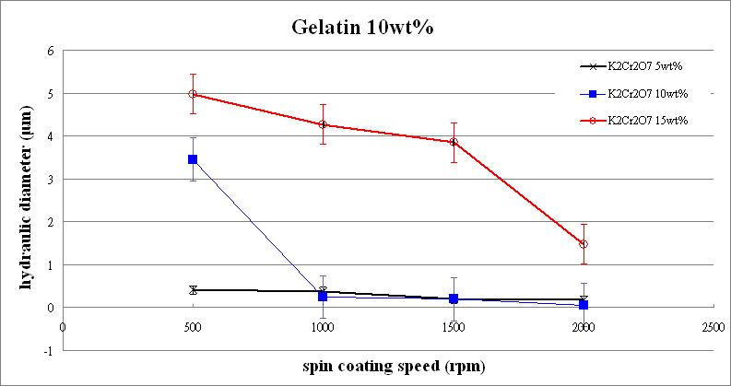
(b)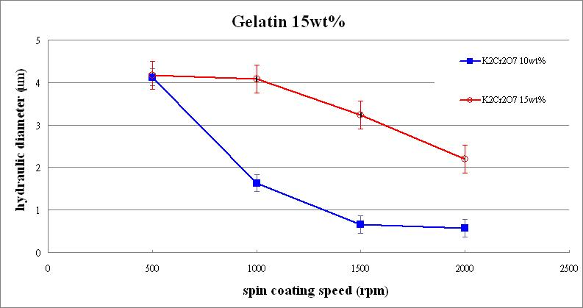
(c)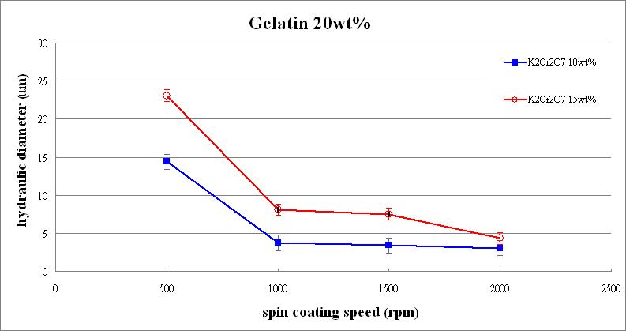
Fig. 2. Hydraulic diameters of the fractal gelatin versus spin coating speed with respect to different dichromate weight percentages: (a) in the 10 wt% gelatin; (b) in the 15 wt% gelatin; (c) in the 20 wt% gelatin.

gelatin film is regarded as a semi-ellipse herein. Therefore all the values of D_{h} are calculated by the elliptic cross section formulas as follows.
$D_{h}=4{A_{c}}/P$ (1)
P≒ π [3(a＋b)－$\sqrt{(3a+b)(a+3b)}$] (2)
A_{c}=πab (3)
where A_{c} and P denote the cross section area and the perimeter of the flow channel under investigation. The values of a and b in (2) and (3) denote the long semi-axis and the short semi-axis respectively of the ellipse. They are quantitatively determined from the scanned curve of the fractal gelatin patterns by SEM or the surface profiler (alpha-step 500). One example is shown in Fig. 3.
From Fig. 2, the fractal gelatin dimension or the hydraulic diameter globally decreases with the increasing coating speed and the lower wt% concentration of gelatin as well as dichromate salt. In Fig. 2(a), the finest hydraulic diameter of
(a)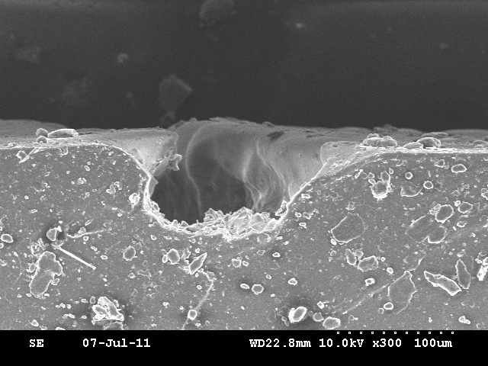
(b)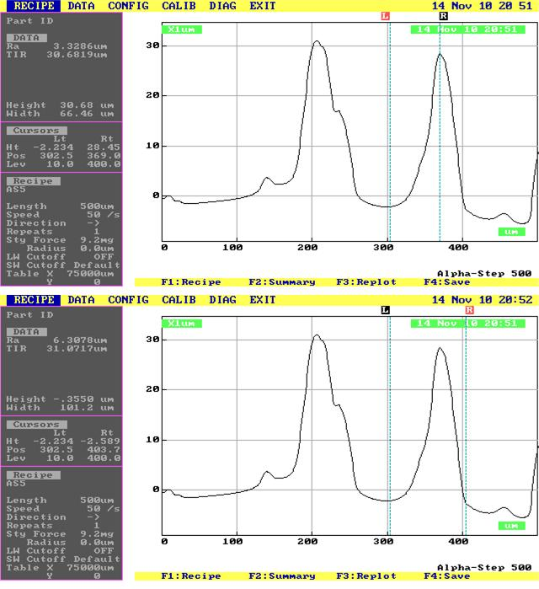
Fig. 3. The gelatin fractal patterns scanned by: (a) SEM; (b) surface profiler. The SEM of (a) is taken from a slice specimen cut from a PDMS block molded by the fractal gelatin. In (b) the height b is 30.68 μm and the width 2a is 101.2 μm.

fractal gelatin branch is 0.1 μm subject to 10 wt% dichromate in 10 wt% gelatin solution spun-coating at 2000 rpm.
Except the case of 10 wt% gelatin solution in Fig. 2(a), there’s no fractal gelatin appeared with the dichromate wt% less than 5%. Additionally, the fractal gelatin dimension changing trend subject to lower wt% behaves more unpredictable in Fig. 2(a-b). Their hydraulic diameters also don’t match with the general blood vessels. Therefore, the thicker case of 20 wt% gelatin solution in Fig. 2(c) is finally chosen as the candidate for the fractal pattern transfer to PDMS in the next section.

Fractal Patterns Transfer to PDMS
Artificial blood vessels with chaotic dendrite tree shape mimicking the portal veins of livers were proposed by Ref. [6]. So far the authors could not find a proper method to fabricate the circular blood vessels directly by the gelatin material. An easier approach is to regard the fractal gelatin as a mother template, and to use the PDMS de-molding technique to transfer the bumped fractal patterns into the concave fractal hollow channels in a PDMS block. The drawback of this method is that the cross section of the fractal channel is only semi-circular. But the elastic PDMS with large deformation capability could somewhat compromise this shortcoming. The PDMS process is shown in Fig. 4. The fabricated PDMS flow chip with fractal channels is shown in Fig. 5. The process parameters for the fractal gelatin are 20 wt% gelatin aqueous solutions with 15 wt% K₂Cr₂O₇ subjected to 500 rpm spin coating speed. According to the process data in Fig. 2(c), the hydraulic diameter of this fractal channel is estimated to be 23 μm.

Water Filling Test
The fabricated PDMS flow chip is performed with water filling to confirm the mechanical strength before the bio-compatible verification. The volumetric flow rate of the syringe pump is set as 5-40 mL/min. The authors observed the width change of the fractal channels under the optical microscope and summarized them in Table 1. The experiment setup and the OM pictures are shown in Fig. 6. As the flow rate is up to 30 mL/min, the width change of 7% is observed. The corresponding pressure drop across the fractal channel is calculated as 6.24 MPa by the Hagen-Poiseuille equation [7].
(a)
$Q={\text{uA}}_{c}=\frac{ΔP⋅π⋅D_{h^{4}}}{\text{128}μL}$ (4)
where Q, u, μ denote the volumetric flow rate, flow speed, and viscosity of the fluid. L is the channel length of the flow channel. △P is the pressure drop across the channel length L (=3.5 mm from Fig. 5.)
This pressure drop △P=6.24 MPa is 4.46 times of the Young’s modulus of PDMS, 1.4 MPa. Therefore the apparent channel deformation is reasonable. The flow speed of 59.3 m/s is far faster than the test speed of 2 mm/s for red blood cells [8], and even tremendously faster than the flow speed of 10 μm/s for tumor cells in capillaries [6]. Therefore the PDMS fractal blood vessels are robust enough to be used in the general biomedical flow filling.

Conclusion
In conclusion, the PDMS artificial blood vessel molded from fractal gelatin patterns has no damage issue subjected to MPa pressure loading so far. The characteristic hydraulic diameter of the chaotic micro channel ranges from 0.1 μm to 23 μm in this work. The potential applications of this fractal channel network include artificial blood vessels, cell culture attachment investigation, and chaotic micro mixers.
Acknowledgment
The authors would like to thank the financial and travel support from the National Science Council of Taiwan with the project no. of NSC-98-2221-E-032-025-MY3.
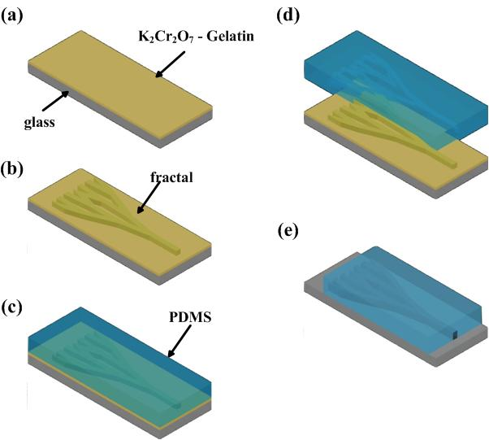
Fig. 4. Process flow of the PDMS fractal channels animating blood vessels. (a) Spin-coating the gelatin film with oversaturated potassium dichromate; (b) Fractal gelatin precipitation and UV exposure; (c) Dispensing PDMS; (d) PDMS de-molding; (e) A glass substrate bonded with the PDMS slide with fractal channel pattern.
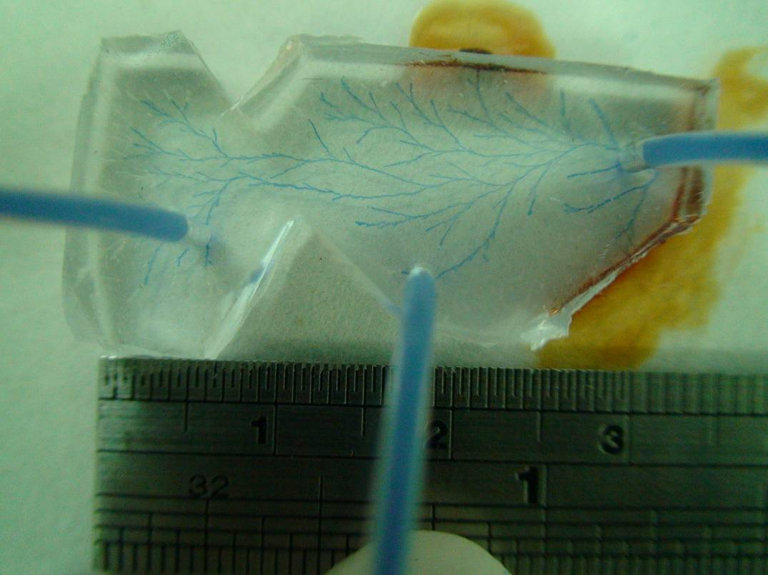
exit ports
entrance
Fig. 5. A filling test of the PDMS fractal channel chip.
TABLE I. The testing results of the filling experiment on the PDMS chip.
Volumetric flow rate Q (mL/min) | Flow speed  u (m/s) | Pressure difference  △P (MPa) | Width change of fractal channels (L=0.035m; μ=1.003mPa‧s)
5 | 10.6 | 1.19 | None (width =100μm)
10 | 21.1 | 2.38 | None (width =100μm)
15 | 31.7 | 3.57 | None (width =100μm)
20 | 42.3 | 4.76 | None (width =100μm)
25 | 52.9 | 5.95 | None (width =100μm)
30 | 59.3 | 6.24 | 7% larger (width =107μm)
35 | 64.4 | 6.30 | 15% larger (width =115μm)
40 | 70.5 | 6.61 | 20% larger (width =120μm)

(a) 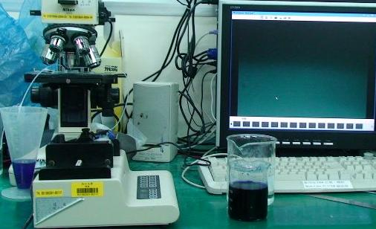
syringe pump
PDMS chip of Fig.5
OM
monitor
waste
(b) 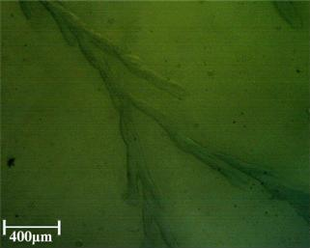
(c) 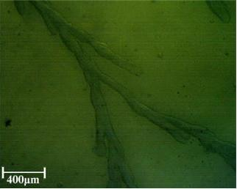
Fig. 6. Water filling experiment to the fractal channel in PDMS: (a) test setup; (b) channel without water filling; (c) channel filled with 35 mL/min water and the width changed with 15%.
References
- L.J. Yang, W.Z. Lin, T.Y. Yao, and Y.C. Tai, “Photo-patternable gelatin as protection layers in surface micromachinings,” Sensors and Actuators A, vol. 103(1-2) pp. 284-290, 2003.
- L.J. Yang and Y.C. Ou, “The micro patterning of glutaraldehyde(GA)-crosslinked gelatin and its application to cell-culture,” Lab on a Chip, vol. 5, no. 9, pp. 979-984, 2005.
- A. Mersmann, Crystallization Technology Handbook, 1st ed., Marcel Dekker, New York, Chapter 1, pp. 48-56, 1995.
- L.J. Yang, C.T. Lee, P.H. Chen, and C.W. Hsu, “Confined fractal patterns in gelatin,” The 6th IEEE International Conference on Nano/Micro Engineered and Molecular Systems (NEMS-2011), art. no. 6017292, pp. 49-52, 2011.
- A.F. Kao, L.J. Yang, F.W. Yeh, “Fractal grooves applied to passive micro-mixers,” The 6th IEEE International Conference on Nano/Micro Engineered and Molecular Systems (NEMS-2011), art. no. 6017315, pp. 142-145, 2011.
- L.J. Yang, C.W. Hsu, and Y.C. Ou, “The minimum time estimation for initiating tumor-cell attachment,” Tech. Dig. of Transducers-2011, Beijing, June 5-9, W3P.104, 2011.
- M.J. Madou, Fundamentals of Microfabrication- The Science and Miniaturization, 2nd ed., CRC Press, Boca Raton, p. 565, 2002.
- T. Secomb, R. Skalak, N. Ozkaya, and J.F. Gross, “Flow of axisymmetric red blood cells in narrow capillaries,” Journal of Fluid Mechanics, vol. 163, pp. 405–423, 1986.

